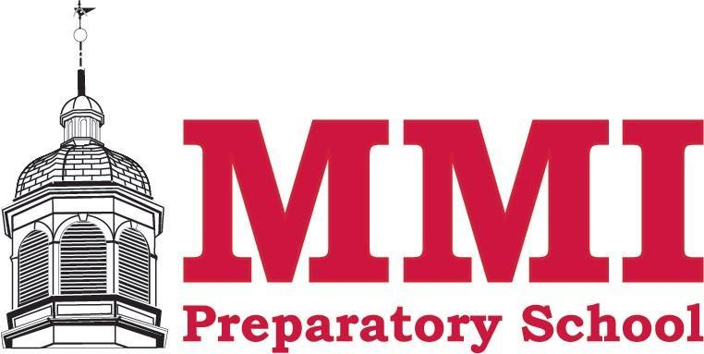

**For immediate release**

Contact: Marci Hosier, Director of Enrollment & Marketing

Phone: 570.636.1108 Fax: 570.636.0742

Visit MMI on the web at www.mmiprep.org

***There is a photo with this press release.***

**MMI Preparatory School Honors the Class of 2024 at 132nd Commencement Ceremony**

**(Freeland, PA — May 23, 2024) —** MMI Preparatory School honored the Class of 2024 during its 132nd commencement ceremony on Thursday, May 23.

This year’s graduating class of 40 seniors were accepted at more than 85 percent of the colleges they applied to and amassed more than $12.5 million in merit scholarships and awards.

Students from the graduating class offered their remarks, with many using “community” as a recurring theme. The class of 2024’s Salutatorian, Abigail Sparich, thanked the communities of Freeland and MMI for providing her with a strong work ethic. She noted that despite being raised in a small town, the class of 2024 can still do big things. She encouraged students to be ready to take on any opportunities that come their way and be willing to do whatever it takes to reach their goals.

Heath Williams, Senior Class President, focused on the community the senior class provided and reminded classmates to be thankful for the opportunities and lessons they have taught each other. He also encouraged students to persevere as they leave MMI and pursue their next journey, remarking, "Let’s embrace the future with the same spirit of adventure and curiosity that brought us to MMI six years ago.”

The Class of 2024’s Valedictorian, Nathaniel Neidlinger, spoke about how the MMI community was there for him as he pushed through difficult times. He highlighted the tight-knit community that MMI has and how it’s helped him in the classroom and in his personal life. Nathaniel remarked that on multiple occasions, he was left speechless by the generosity they showed him.

MMI Alumnus, Maura (Kurtz) Hodge ‘00, gave the Founders Day Address and mentioned the MMI community while providing tips for students once they walk through the School’s halls for the last time. She recounted her time at MMI and provided the experiences she believed truly helped her flourish in her post-high school career. Hodge recognized the challenges the class of 2024 experienced and offered advice on how they can handle those obstacles moving forward; “Press into those feelings and process them with your tribe. Growth and change come out of challenge – aim for progress, not perfection…”. As she wrapped up, she ended with words of encouragement: “Dream big for yourselves, for your communities, and for the world. Go and make your mark - one person at a time!”

Members of MMI’s Class of 2024, their parents, and their hometowns are as follows:

Diane Arias Tejeda, child of Angela Tejeda of Hazleton; Teagan Bonham, child of Craig and Melissa Bonham of Sugarloaf; Emily Borchick, child of Lance and Cindy Borchick of Drums; Phoebe Bramley, child of Samantha Bramley of Blakeslee; Brendon Brobst, child of Molly Brobst of Mountain Top and Kevin Brobst of Sugarloaf; Andrew Burns, child of Jill Burns of White Haven; London Chehovich, child of Michael Chehovich of Drums and Jessica Quinn of Hazle Township; Ryan Clymer-Sones, child of Brian and Amber Sones of White Haven; John Drobnock III, child of John and Lani Drobnock of West Hazleton; Reed Floryshak, child of Roxanne Floryshak of Conyngham and Aaron Floryshak ‘95 and Grete Floryshak ‘92 of Sugarloaf; Jagjit Gondara, child of Parminder Kaur and the late Harinder Singh of Hazle Township; Caylee Herseim, child of Jeremy and Casey Herseim of Hazle Township; Emily Hunsinger, child of Timothy and Shannon Hunsinger of Sugarloaf; Angelica Jimenez, child of Tania Castillo of Hazleton; Kyle Kocon, child of Chris and Ivona Kocon of Mountain Top; Eric “Woobie” Kupsky, child of Lori Blue and Colby Vonderheid of Bear Creek Township; Caitlin Lenahan, child of David DelRegno and Margaret Lenahan of Mountain Top; Lex Lispi, child of Tino Lispi and Fran Fasching of Lake Harmony; Ethan Lloyd, child of Robert Lloyd of Meshoppen and Michael and Wendy Storaska of Drums; Edgar Lopez-Rodriguez, child of Eduart Lopez and Veronica Rodriguez of Hazle Township; Kade Lutz, child of Jeff and Shelly Lutz of Lake Harmony; Jordan Mulhall, child of James Mulhall and April Cook of Freeland; Nathaniel Neidlinger, child of Amanda Neidlinger 98’ of Weatherly; Alex Neyhart, child of Paul and Joyce Neyhart of Hazleton; Paul Neyhart Jr., child of Paul and Joyce Neyhart of Hazleton; Robert Orbin III, child of Robert and Lynn Orbin of Mountain Top; Kasra Paknezhad, child of Dr. Hassan Paknezhad and Elham Naghdi Sedeh of Mountain Top; Sophia Plonk, child of Jeremy and Andrea Plonk of Hazle Township; Dominic Raifsnider, child of Patricia Suveg of Lake Harmony; Jakob Rossi, child of Sue Rossi of Drums; Jason Salio, child of Joseph and Tracy Kress of Sugarloaf and Sylvester Salio of Swoyersville; Kathryn Sissick, child of Thomas Edwards and Michelle Mendofik of Drums and Jeffrey Sissick of McAdoo; Nathan Sissick, child of Thomas Edwards and Michelle Mendofik of Drums and Jeffrey Sissick of McAdoo; Abigail Sparich, child of Joseph and Michele Sparich of Weatherly; Connor Strecker, child of Peter and Tara Strecker of Mountain Top; Sun Wang, child of Xiaojing Fang and Chang Wang of Weatherly; Blake Warren, child of Atty. Rebecca Warren '84 of Beaver Meadows and Richard Warren of Danville; Heath Williams, child of Atty. Richard Williams and Shannon Williams of Mountain Top; Zachary Yenchko, child of George and Mary Sharon Yenchko of Freeland.

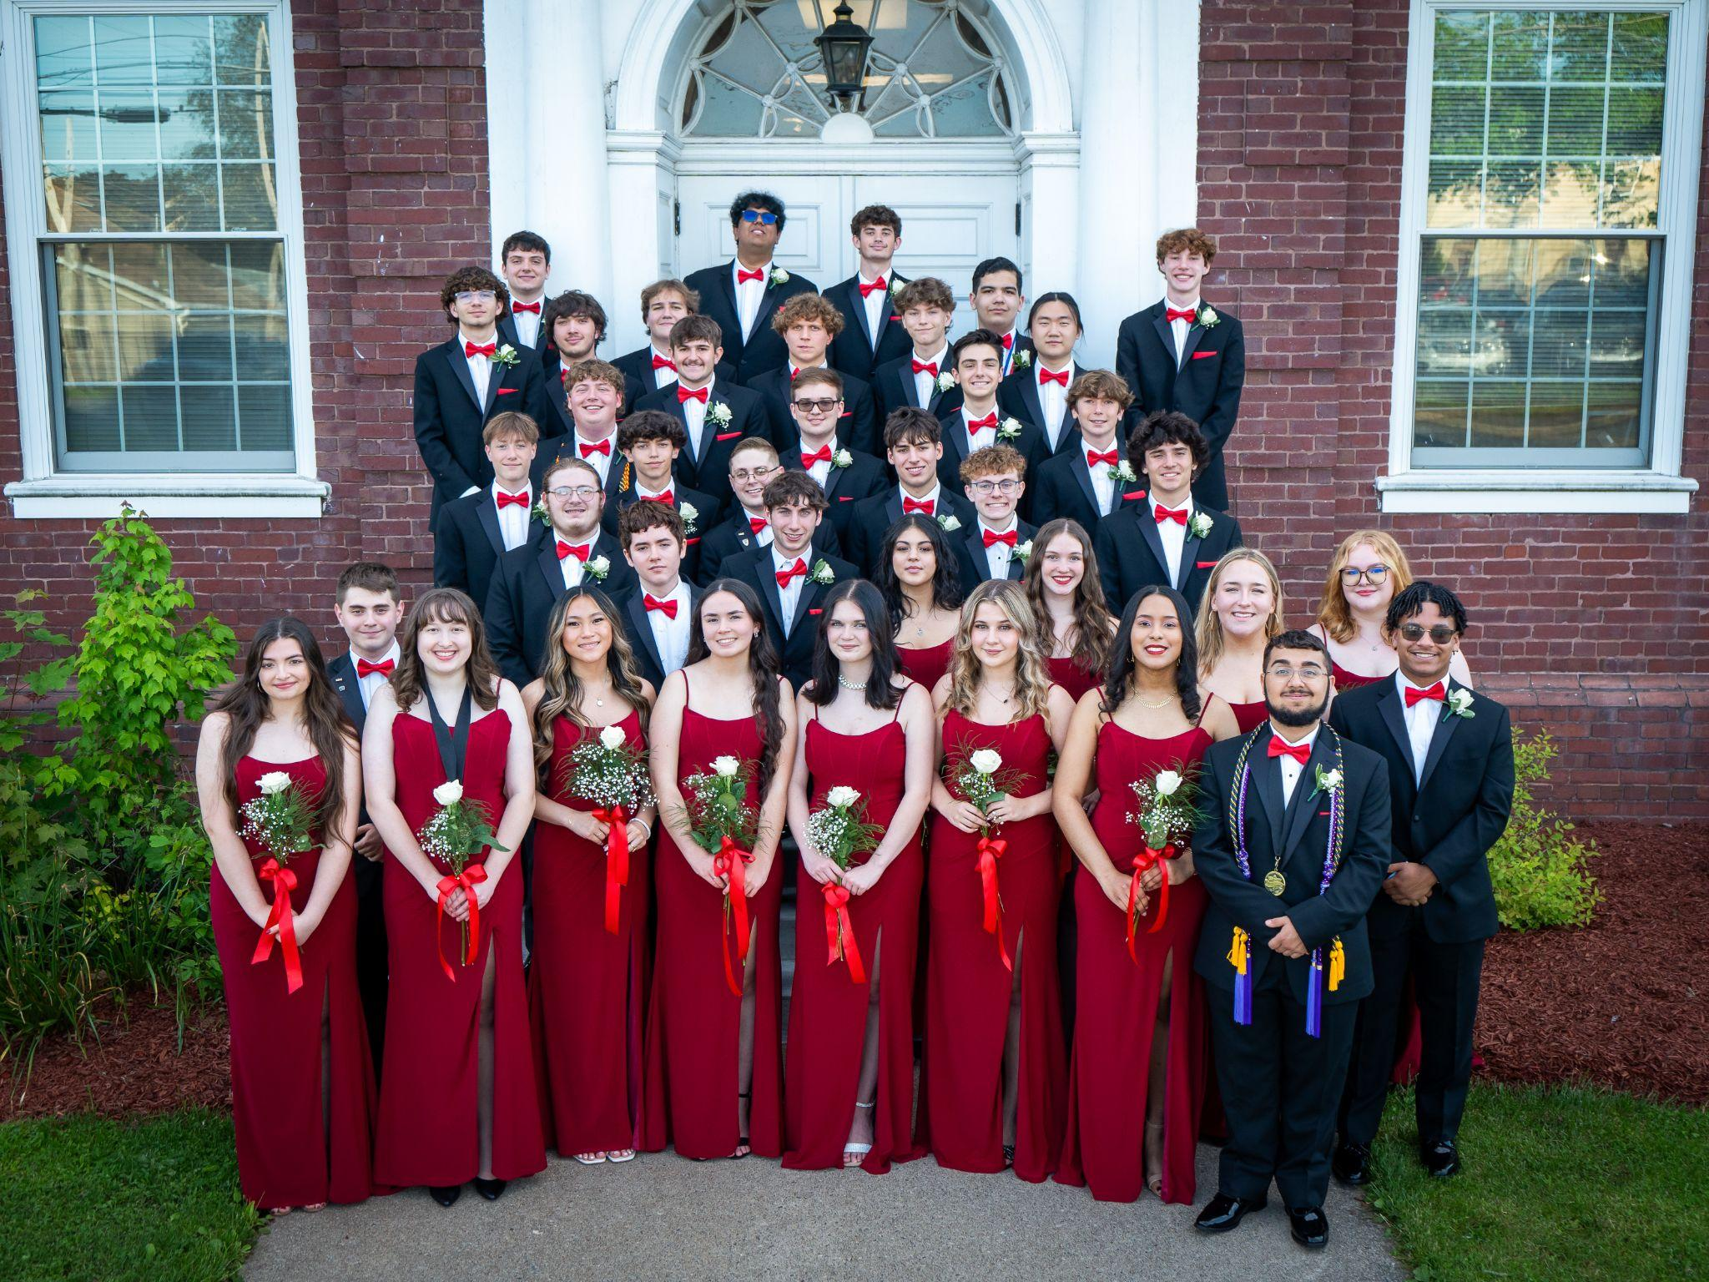

**#####**

**About MMI Preparatory School**

For 145 years, MMI Preparatory School has been providing dedicated area students with a comprehensive and inspiring 6th through 12th-grade college preparatory program that maximizes each individual’s academic, social, and character potential in preparation for success in college and beyond. The school is accredited by the Pennsylvania Association of Independent Schools (PAIS) and the Middle States Association of Colleges and Schools Commissions on Elementary and Secondary Schools (M.S.A.-C.E.S.S.). MMI is a school where every student can reach their full potential: academically, ethically, and socially. For more information about MMI Preparatory School, visit [www.mmiprep.org](http://www.mmiprep.org/) or call 570-636-1108.